Laravel Routing 2019-02-19

Routing en tabel doorgeven voor andere view

Aanpassen:

Web.php

xxx.blade.php

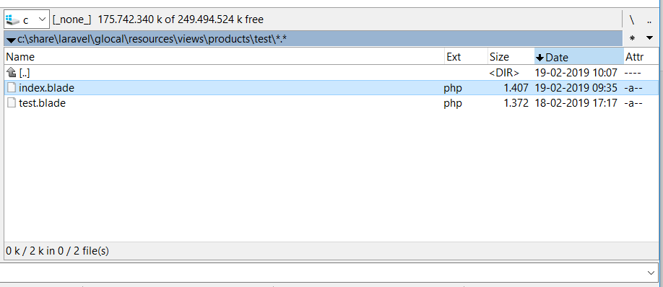

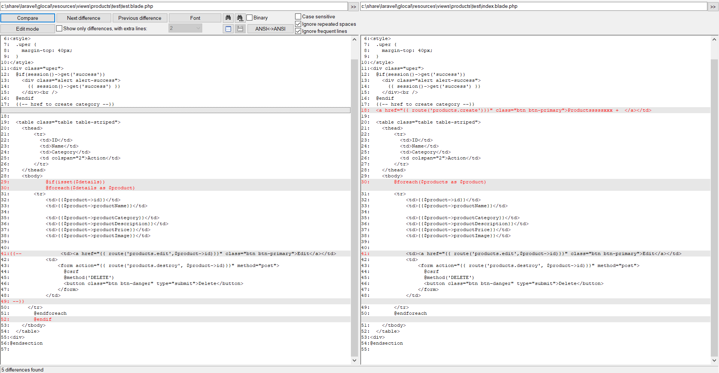

Route::get('/productsx', function () {

$products=Product::all();

return view('products.users.test' )->withDetails($products);

});

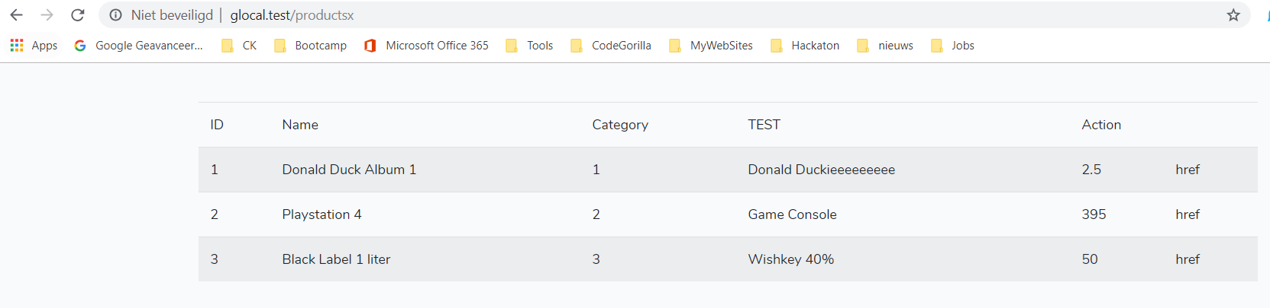

Route::get('/productsx', function () {

$products=Product::all();

return view('products.users.index' )->withDetails($products);

});

